EXPERIMENT-6-Order Management System

Aim:
To develop a cloud-based system to manage customer orders and product details.
Procedure:
- Created Product and Customer forms to store details.
- An Order form was developed using lookup fields to connect products and customers.
- Fields like quantity and status were added.
- Sample data was inserted and orders were tested.
- Reports were used to verify output.
Output
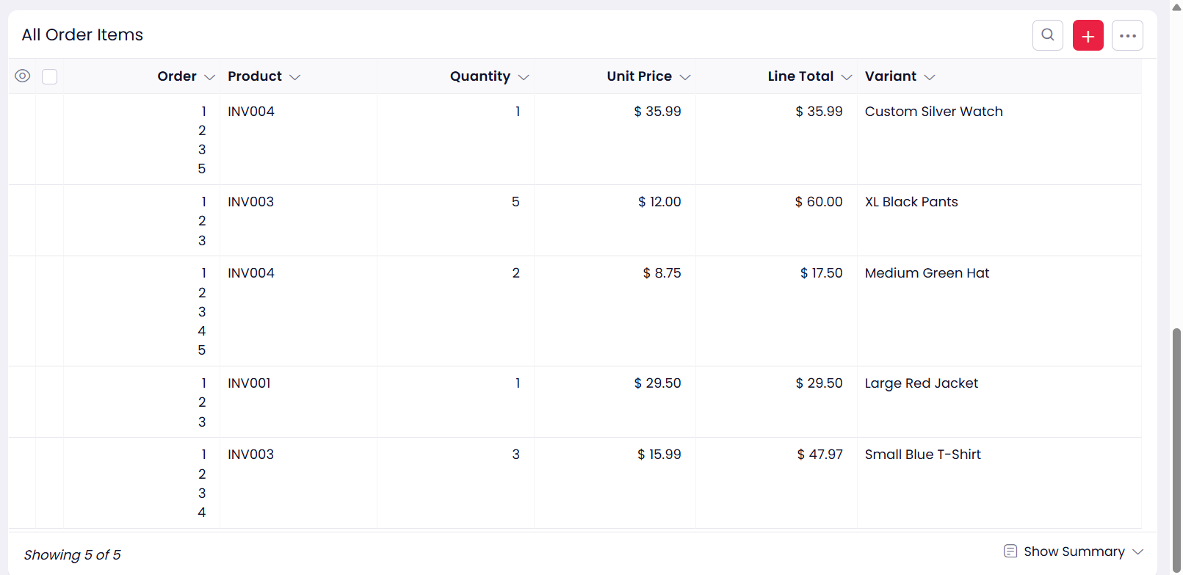

Result:
Order management system successfully handles and displays order details in table format.

